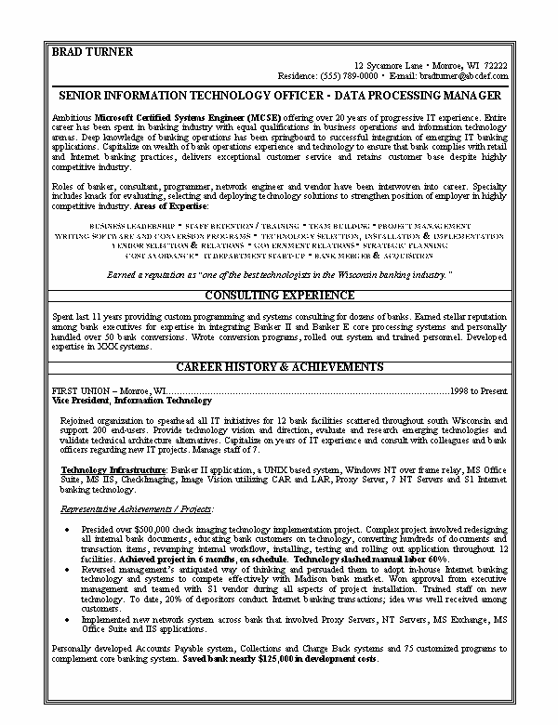
BRAD TURNER
12 Sycamore Lane Monroe, WI 72222 Residence: (555) 789-0000 E-mail: bradtumer@abcdef.com
SENIOR INFORMATION TECHNOLOGY OFFICER - DATA PROCESSING MANAGER
Ambitious Microsoft Certified Systems Engineer (MCSE) offering over 20 years of progressive IT experience. Extire career has been spent in banking industry with equal qualifications in business operations and information technology arenas. Deep knowledge of banking operations has been springboard to successful integration of emerging IT banking applications. Capitalize on wealth of bank operations experience and technology to ensure that bank complies with retail and Internet banking practices, delivers exceptional customer service and retains customer base despite highly competitive industry.
Roles of banker, consultant, programmer, network engineer and vendor have been interwoven into career. Specialty includes knack for evaluating, selecting and deploying technology solutions to strengthen position of employer in highly competitive industry. Areas of Expertise:
BUSINESS LEADERSHIP STAFF RETENTION / TRAINING: * TEAM BUILDING " PRONEST MANAGEMENT WRITING SOFTWARE AND CONVERSION PROGRAMS • TECHNOLOGY SELECTION, INSTALLATION & ISPLEMENTATION YENİKƏR XELESTIAS & RELATIANS * 1209 ERNMENT RELATIANS” STRATBACK FLANSING POST AVOIDANCE. IT DEPARTMENT START-UP BANK MERTER & SALISITION
Earned a reputation as "one of the best technologists in the Wisconsin banking industry."
CONSULTING EXPERIENCE
Spent last 11 years providing custom programming and systems consulting for dozens of banks. Eamed stellar reputation among bank executives for expertise in integrating Banker II and Banker E core processing systems and personally handled over 50 bank conversions. Wrote conversion programs, rolled out system and trained personnel. Developed expertise in XXX systems.
CAREER HISTORY & ACHIEVEMENTS
FIRST UNION Monroe, WI.... Vice President, Information Technology
.1998 to Present
Rejoined organization to spearhead all IT intiatives for 12 bank facilities scattered throughout south Wisconsin and support 200 end-users. Provide technology vision and direction, evaluate and research emerging technologies and validate technical architecture alternatives. Capitalize on years of IT experience and consult with colleagues and bank officers regarding new IT projects. Manage staff of 7.
Technology Infrastructure: Banker II application, a UNIX based system, Windows NT over frame relay, MS Office Suite, MS IIS, CheckImaging, Image Vision utilizing CAR and LAR, Proxy Server, 7 NT Servers and S1 Internet banking technology.
Representative Achievements / Projects:
•
Presided over $500,000 check imaging technology implementation project. Complex project involved redesigning all internal bank documents, educating bank customers on technology, converting Famdreds of documents and transaction items, revamping internal workflow, installing, testing and rolling out application throughout 12 facilities. Achieved project in 6 months, on schedule. Technology slashed manual labor 60%. Reversed management's antiquated way of thinking and persuaded them to adopt in-house Internet banking technology and systems to compete effectively with Madison bank market. Won approval from executive management and teamed with S1 vendor during all aspects of project installation. Trained staff on new technology. To date, 20% of depositors conduct Internet banking transactions; idea was well received among
customers.
Implemented new network system across bank that involved Proxy Servers, NT Servers, MS Exchange, MS Office Suite and IIS applications.
Personally developed Accounts Payable system, Collections and Charge Back systems and 75 customized programs to complement core banking system. Saved bank nearly $125,000 in development costs.

